DESIGN DOCUMENT

Apartment gate app

Explanation :

Every visitor will have to get registered at the security before entering the apartment.

Visitor can be of 2 types: VISITOR and DELIVERY

On successful registration of visitor by security, the concerned resident will be notified about the visitor

Resident can view the list of visitors visited. The list can be paginated and filtered based on from and to date.

Assumptions:

Each person is considered to be a new Visitor every time he/she visits.

Technical Details:

Git hub Link : https://github.com/kashyappvb/security_guard.git

Before Start :

INSERT INTO RESIDENT(RESIDENT_ID,RESIDENT_NAME) VALUES (1,’RESIDENT 1’);

INSERT INTO RESIDENT(RESIDENT_ID,RESIDENT_NAME) VALUES (2,’RESIDENT 2’);

INSERT INTO RESIDENT(RESIDENT_ID,RESIDENT_NAME) VALUES (2,’RESIDENT 3’);

**Postman is the client used to call REST service.**

**Register Visitor:**

Use MULTIPART_FORM_DATA_VALUE to send required data to register the Visitor

HTTP protocol: POST

End Point: localhost:8080/appartement/guest

Use “file” as key to upload image.

Use “guest” as key to upload JSON request file.

On successful registration, Image URL and Guest ID will be returned

Success response:

{

"guestId": 1,

"guestImagePath": "\path\to\image\IMG_20191125_153654.jpg"

}

Failure Response:

{

"message": "Failed",

"details": [

"Resident with ID : 5 is not present!"

],

"time": "2021-05-20T07:35:32.590+00:00",

"status": "400 BAD_REQUEST"

}

**Image Size > 5**

{

"message": "Failed",

"details": [

"File Upload Limit up to 5MB”

],

"time": "2021-05-20T07:38:32.590+00:00",

"status": "400 BAD_REQUEST"

}

**List of Visitors for Resident:**

HTTP protocol: GET

End Point:

* <http://localhost:8080/resident/1/guest-list> (Pagination will be default set – Page = 1 and size=5 )
* <http://localhost:8080/resident/1/guest-list?page=1&size=10>
* <http://localhost:8080/resident/1/guest-list?page=1&size=10&from=19-05-2021> (if to is not specified, to will be current date)
* http://localhost:8080/resident/1/guest-list?page=1&size=10&from=19-05-2021&to=19-05-2021

Success Response:

**{**

**"visitor": [**

**{**

**"guestId": 1,**

**"name": "Visitor 1",**

**"guestType": "VISITOR",**

**"contactNumber": "+91 7411220032",**

**"createdOn": "2021-05-20T07:44:58.591+00:00",**

**"residentId": 1,**

**"guestImagePath": "path\to\image\visitor_sample.jpg"**

**}**

**],**

**"delivery": [**

**{**

**"guestId": 2,**

**"name": "Visitor 1",**

**"guestType": "DELIVERY",**

**"contactNumber": "+91 7411220032",**

**"createdOn": "2021-05-20T07:45:06.152+00:00",**

**"residentId": 1,**

**"guestImagePath": " path\to\image\delivery_sample.jpg"**

**}**

**]**

**}**

**Failure response :**

**From date ahead of to date :**

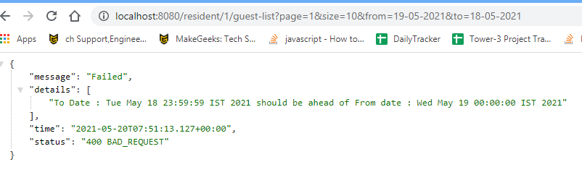

**Resident Notification:**

HTTP Protocol: GET

End Point: <http://localhost:8080/resident/1/notification>

Success response:

First Notification : As resident is looking into the notification for first time, both notification comes under newNotification array.

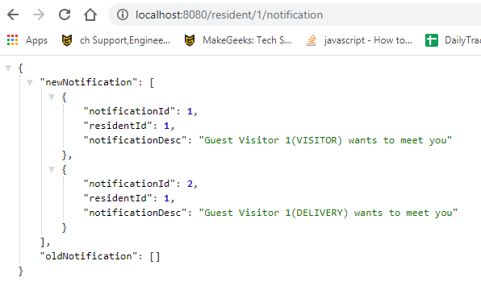

Next visitor comes to the same resident, then notification di 1,2 will move to oldNotification, and next visitor will come to new notification as it s a new notification to resident that a new visitor has come

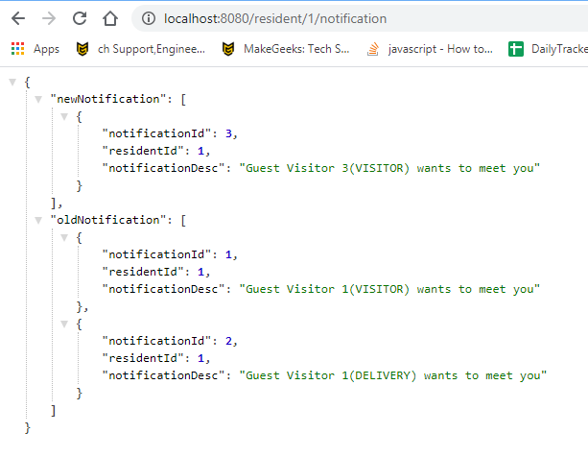

In Memory Database

<http://localhost:8080/h2-console>

Actuator :

<http://localhost:8080/actuator/>

Sample Screenshot for registering User :

